**Building Layout**

We have created divided rooms with the use of Japanese art dividers. The specific usage of Japanese art dividers is aligned with the authentic Japanese theme of our restaurant.

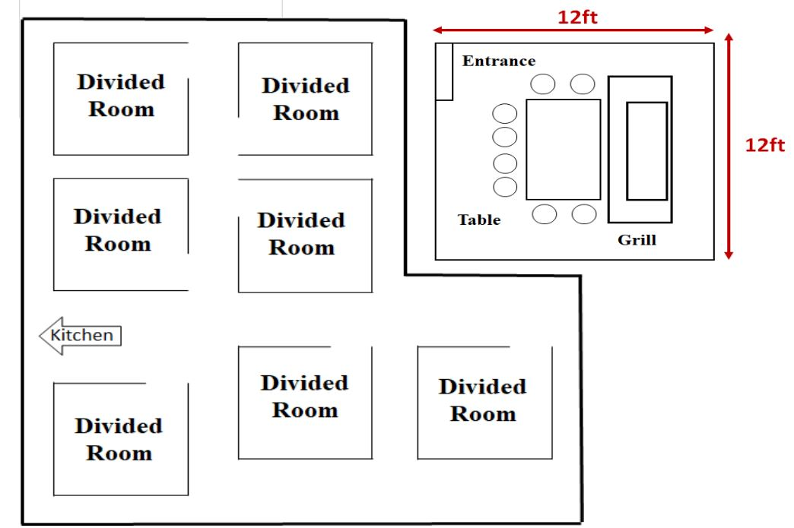

There will be a plastic barrier around the grill for extra protection as the chef uses a 5-6-foot spatula to pass the hibachi to the customer. At the entrance of every divided room will be sanitary items such as disinfecting wipes and hand sanitizers.